صورة تحتوي على رمز, الخط, شعار, الرسومات

تم إنشاء الوصف تلقائياً

**Kingdom of Saudi Arabia**

**Ministry of Education**

**Umm Al-Qura University**

**College of Engineering and Computers**

**(Department of Computer Science)**

**[Blackboard]**

**[ 2024 ]**

**Student name:**

**Fatimah Al-Jedaani (444014738)**

**Shahad Ali (444009300)**

**With the rapid development of information technology, Learning Management Systems (LMS) have become an essential part of enhancing the educational process. Among these systems, the Blackboard application is one of the most prominent educational tools widely used in universities and educational institutions around the world. This application allows students and faculty members to access educational content, submit assignments, participate in discussions, and manage various aspects of the academic process smoothly and effectively.**

**In this report, we will review the various types of key features and characteristics of the Blackboard application, and how it contributes to improving the teaching and learning experience, focusing on the benefits it provides to both teachers and students.**

**Report Content:**

* 1. **Introduction…………………………………………………………….3**
  2. **Purpose………………………………………………………………….3**
  3. **Stakeholders……………………………………………………………3**
  4. **Main tasks of Blackboard…………………………………………….3**
  5. **Requirements…………………………………………………………...3**
  6. **The reason for the existence of blackboard ..…………………….4**
  7. **Problems Resolved by Blackboard…………………………………4**
  8. **Questionnaire…………………………………………………………...5**
  9. **Comparison between Blackboard and Madrasty………………….7**

**10. Conclusion ……………………………………………………………..10**

**11. References……………………………………………………………..10**

**[Chapter 1]**

Blackboard Learn provides an easy way to interact with different types of features, depending on your role, either as an instructor or a student.

* 1. **Introduction:**

Blackboard is one of the modern educational applications in the modern era, as it provides a comprehensive platform for e-learning and manages educational content online. This program is used in many educational institutions around the world, ranging from multi-access educational institutions to higher education institutions.

* 1. **Purpose:**

The primary purpose of Blackboard is to facilitate content management, delivery, and assessment, featuring a variety of educational tools for seamless access to course materials, assignments, discussions, and assessments.

* 1. **Stakeholders:**
* User (Student -Teacher)
* Distance learning team
  1. **Main tasks of Blackboard:**

1. Blackboard allows instructors to create and manage courses. This includes organizing and uploading course materials such as syllabi, lecture notes, and multimedia content.

2. Blackboard provides a variety of communication tools. This includes discussion boards, messaging systems, and announcements.

3. Blackboard supports a range of assessment types, including quizzes, tests, and assignments. also provides automatic grading for certain assessments and provides tools for manual grading and feedback.

* 1. **Requirements**

1. The system shall be easy to use and understandable for users regardless of their technological experience
2. User data must be well protected and secured
3. The system shall be Quick response
4. The system shall be available 24 hours

**[Chapter 2]**

Blackboard is the leading learning management system (LMS), providing a powerful platform for institutions to create, manage, and deliver online courses that foster an interactive and engaging learning experience. This assignment will show you why Blackboard exists, and introduce some of the features and problems it solves.

* 1. **The reason for the existence of blackboard**

Blackboards creation was driven by the need for a more efficient and effective way to deliver education. Traditional classroom settings were often limited by geographical constraints, time constraints, and the availability of resources. Blackboard aimed to address these limitations by providing a flexible and scalable platform for online learning.

* 1. **Problems Resolved by Blackboard**
* Accessibility: Blackboard has made education more

accessible students who live in remote areas or have disabilities

* Flexibility: It offers students the flexibility to learn at their own pace and on their own schedule
* Cost-Effectiveness: By reducing the need for physical classrooms and materials Blackboard can help institutions save costs
* Collaboration: Blackboard fosters collaboration among students and instructors, promoting a more interactive and engaging learning experience
  1. **Questionnaire**

**conducted a survey to collect opinions about the blackboard application:**

Figure 1 . Shows details to describe the interface used and the speed of this system.

**صورة تحتوي على نص, لقطة شاشة, رقم, الخط

تم إنشاء الوصف تلقائياً**

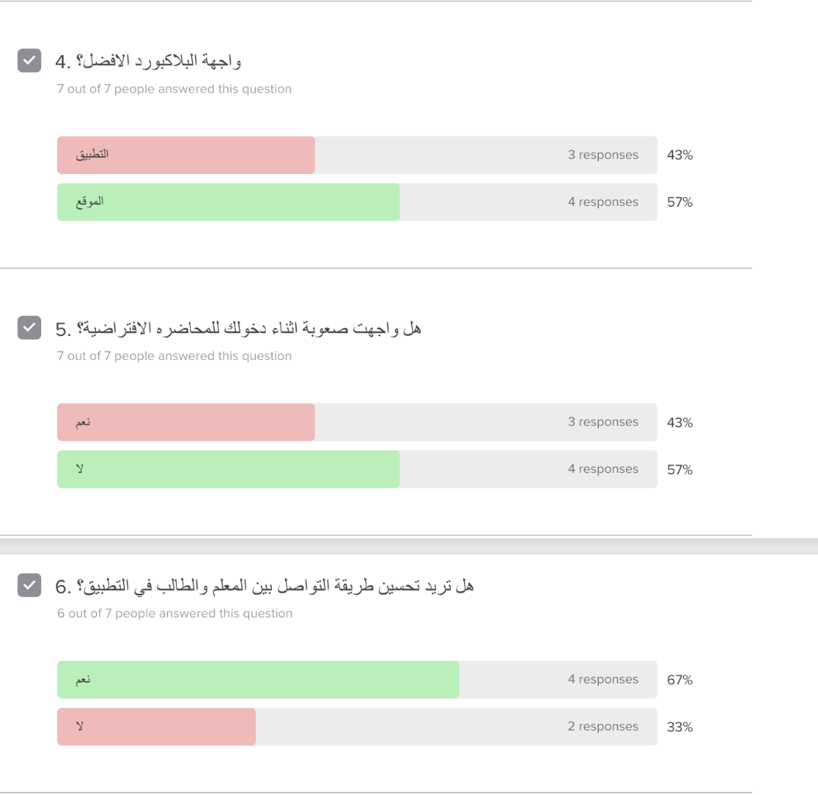

Figure 2 . Shows the difficulty level of entering the lecture and communicating with teachers.





Figure 3 . Illustrates the additional features and problems of using Blackboard.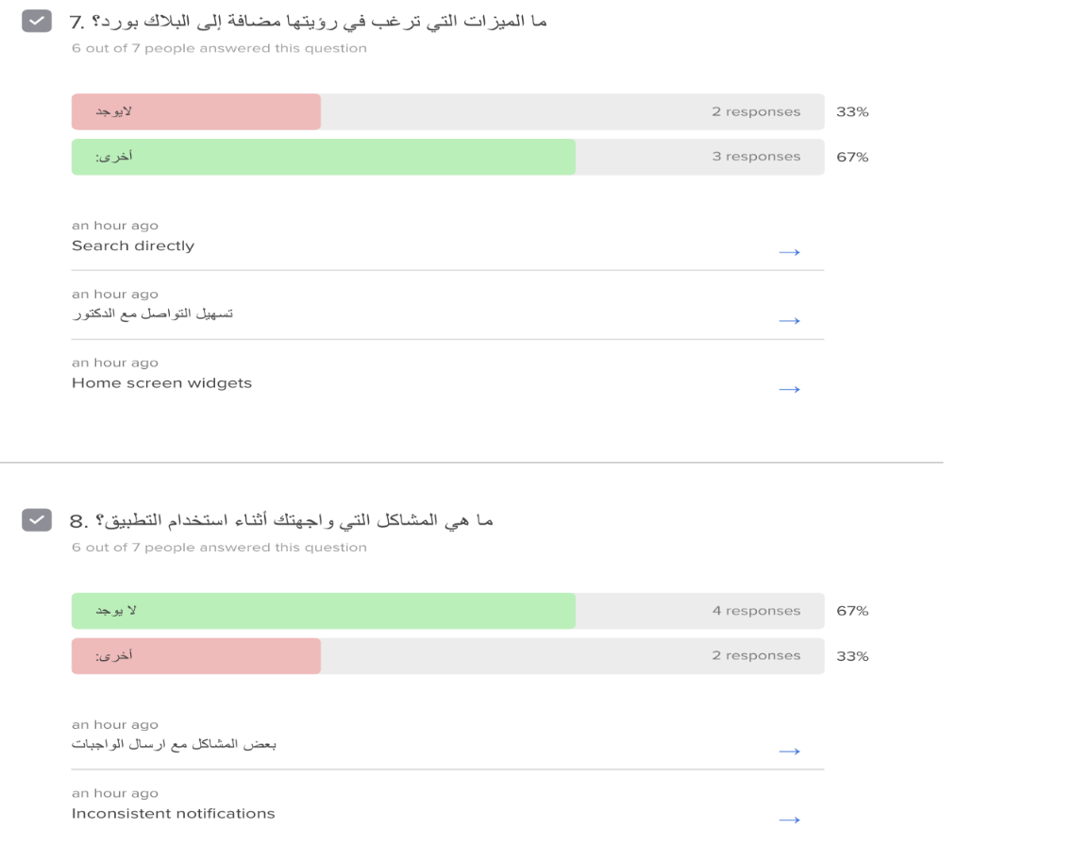

A survey was conducted to collect opinions about Blackboard, and some problems were identified such as difficulty in dealing with the system and some technical problems. Based on the survey, we need to modify and improve the user interface, the speed of the program, and the methods of communication between teachers and students in the application.

We also need to modify and add some features to the way teachers and students communicate with each other:

Facilitate communication with teachers

Live search

Tools on the home screen

Problems we faced while using the application

Some problems in submitting assignments

Inconsistent notifications

Explains the differences between blackboard and madrasty in terms of advantages and disadvantages.

* 1. **Comparison between Blackboard and Madrasty**

Blackboard and Madrasty are both popular educational platforms designed to enhance teaching and learning experiences. However, they offer distinct features and cater to different needs. Lets compare their advantages and disadvantages:

**Blackboard**

* + **Advantages:**
* Widely used and established: Blackboard has been a staple in many educational institutions for years, making it a familiar platform for both students and faculty.
* It offers a comprehensive suite of tools, including course management, online testing, discussion forums, and collaboration features.
* Blackboard can integrate with other educational tools and systems, such as learning management systems (LMS) and student information systems (SIS).
* **Disadvantages:**
* The interface can be complex for new users due to its extensive features.
* Like any large-scale platform, Blackboard can encounter technical issues.

**Madrasty**

* **Advantages:**
* Madrasty has a user-friendly interface, designed to be intuitive and easy to navigate, making it accessible to users of all ages.
* The app is optimized for mobile devices, allowing students to access their courses and assignments on the go.
* Madrasty is specifically tailored for Arabic-speaking users, providing features and content relevant to their needs.
* **Disadvantages:**
* It may not offer the same breadth of features like Blackboard.
* Madrasty might have a smaller user community and fewer resources available.

|  |  |  |
| --- | --- | --- |
|  | Blackboard | Madrasty |
| Security | -Both employ security measures to protect user data  -Use secure login and authentication processes  -Regularly update systems to address vulnerabilities  -Comply with relevant data protection regulations | |
| Platform | Web-based, mobile apps, integrates with third-party tools, comprehensive LMS | Primarily mobile app, web version available, focuses on Middle East and North Africa |
| Management | -Both provide centralized systems for managing courses, users, content, and assessments  -Allow administrators to manage user roles and access control  -Offer tools for tracking student progress and performance | |

The following table is a comparison between Blackboard and madrasty in terms of security, platform, and management.

**[Chapter 3]**

The blackboard application database includes all users.

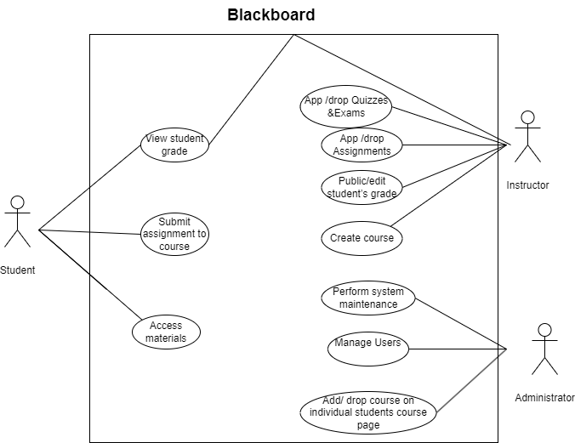

The database is selected according to the needs of the educational institution, the volume of data and the required. It includes more than one million searches voluntarily submitted by blackboard client organizations to work on preventing plagiarism between organizations. It uses relational data to manage and store data related to information for students, teachers, assessments, lectures and tests .The database is separate from the internal database of each organization

It also includes the data models used (such as Microsoft SQL Server, My SQL)

Database systems often used in the application include:

* Microsoft SQL Server: A popular database in educational systems, providing good performance and scalability.
* MySQL: An open source database used in many educational applications for its flexibility and ease of management.

The Blackboard application relies on a variety of programming languages ​​to develop the platform, including the most prominent programming languages ​​used (such as Java script, PHP, and SQL).

The languages ​​and technologies often used in the application include the following:

* JavaScript: It is used in the front-end to interact with users and develop dynamic interfaces. Libraries and frameworks such as React or Angular are also used to improve the user experience.
* PHP: It may be used in some legacy applications or in specific cases such as systems that need compatibility with certain applications or services.
* SQL: It is used to query and interact with databases, whether relational such as MySQL or Oracle.
  1. **Conclusion**

Blackboard has emerged as a powerful tool for education, transforming the way knowledge is shared and acquired. By providing a comprehensive suite of features, Blackboard has addressed many of the challenges faced by traditional education systems. As technology continues to evolve, Blackboard is likely to play an even more significant role in shaping the future of education.

* 1. **References**
* Blackboard Inc. (n.d.). Blackboard. Retrieved from <https://www.blackboard.com/>
* Educational Technology Solutions. (n.d.). Blackboard: A comprehensive guide. Retrieved from <https://www.blackboard.com/>
* University of Michigan. (n.d.). Blackboard help. Retrieved from <https://dataguide.umflint.edu/services/view/13>
* The Chronicle of Higher Education. (2023). Blackboard's new CEO aims to reimagine higher education. Retrieved from <https://www.chronicle.com/>